Ann Heberle O'LONE b 1945 d 2015 Clearwater FL
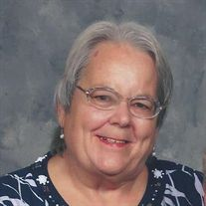
of Clearwater, passed away peacefully Jan. 5, 2015. She moved here from Pennsylvania in 1979 with her husband of 51 years, Richard. She had a generous spirit and volunteered at hospice, worked as a nurse's aid and enjoyed her Church fiat bible study group. Ann is predeceased by Richard, Bud, and Peggy. Survivors include her husband, Richard; sons, Steve (Linda), Don (Jeanne); daughter, Debbie Zuck (Ron); brothers, James and Paul; sisters, Eileen and Brink. Ann will be missed by family and friends.

